Exercise 10: How to install MongoDB Shell & MongoDB Compass
MongoDB Shell (mongosh) is an interactive JavaScript interface to MongoDB, which allows you to query and update data and perform administrative operations. MongoDB Compass is a graphical client that provides a GUI to interact with your MongoDB databases.

Introduction
This guide will walk you through the installation process for MongoDB Shell and MongoDB Compass on your system.

Requirements
- Internet Connection: To download the necessary software.
- Supported Operating System: MongoDB and MongoDB Compass are supported on Windows, macOS, and Linux.
- System Permissions: You might need administrative or superuser privileges to install the software.

Steps to Install MongoDB Shell

Download MongoDB Shell
- Go to the official MongoDB Download Center: MongoDB Download Center
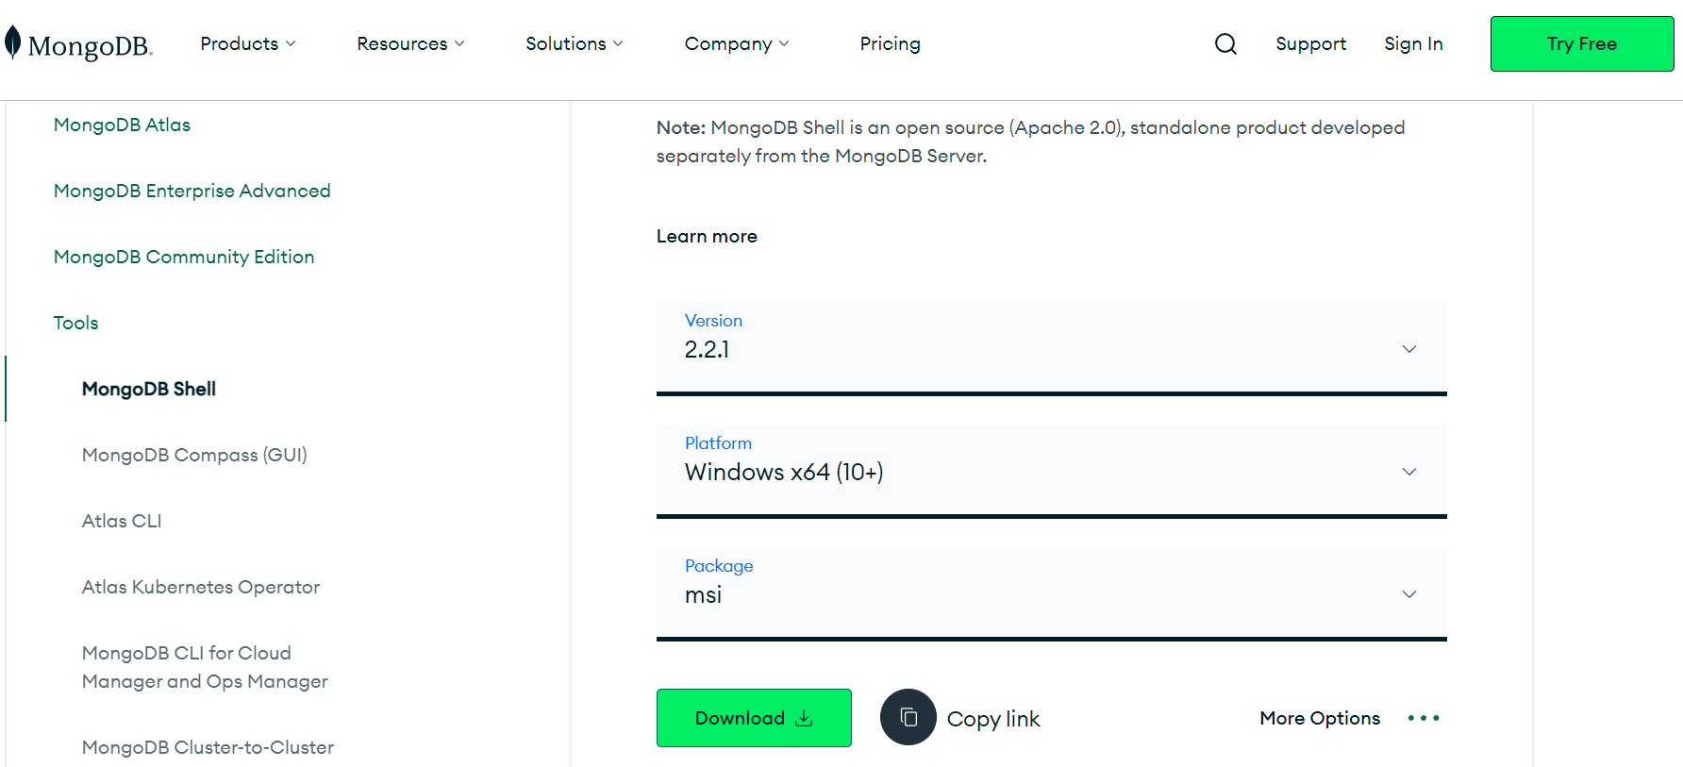
- Choose your operating system from the dropdown menu.
- Click the "Download" button.

Install MongoDB Shell
- Windows: Run the downloaded .msi installer and follow the installation wizard.
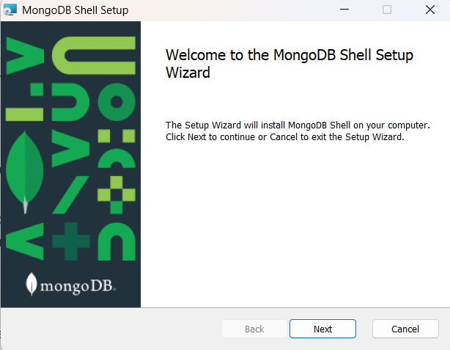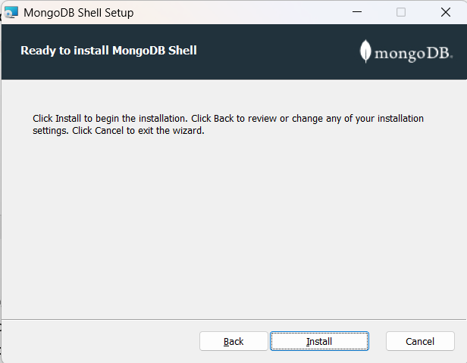
- macOS: Open the downloaded .tgz file, then drag and drop the mongosh binary to your preferred location.
- Linux: Extract the downloaded .tgz file and move the mongosh binary to a directory in your PATH (e.g., /usr/local/bin).

Create an environment variableVerify Installation
Now we go to the location where MongoDB installed in step 2 in your system and copy the bin path:
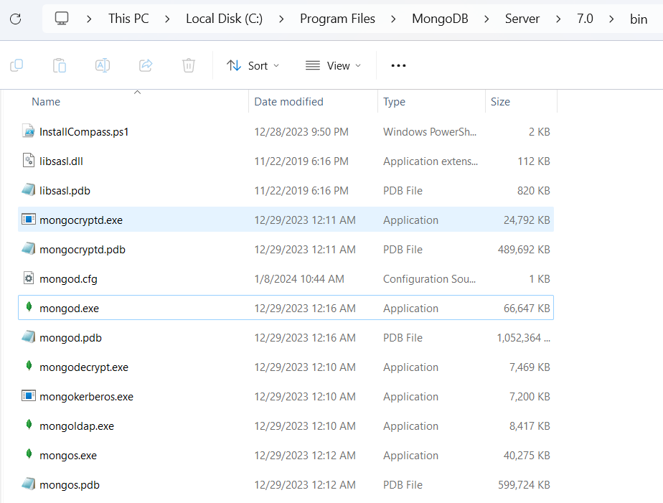
Now, to create an environment variable open system properties << Environment Variable << System variable << path << Edit Environment variable and paste the copied link to your environment system and click Ok:
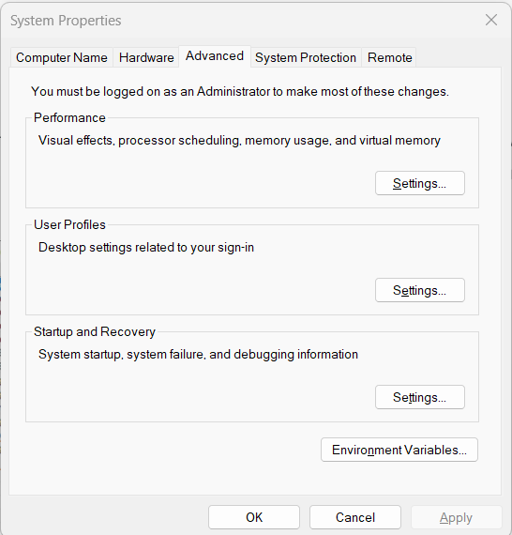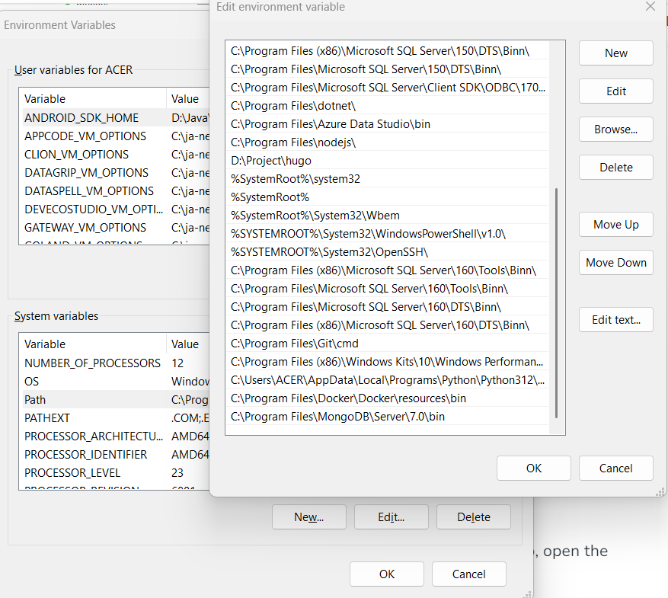

Run the MongoDB server
After setting the environment variable, we will run the MongoDB server, i.e. mongod. So, open the command prompt and run the following command:
Mongod
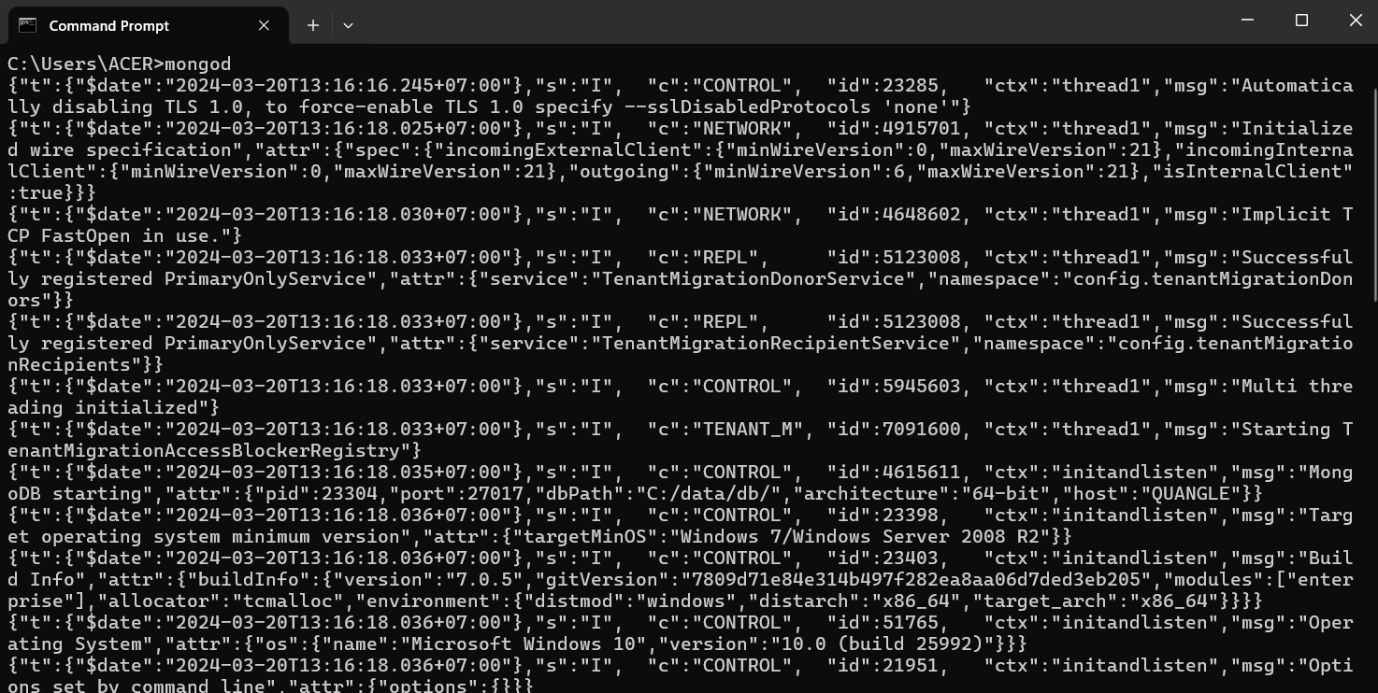

Steps to Install MongoDB Compass

Download MongoDB Compass
- Navigate to the MongoDB Compass download page: MongoDB Compass Download
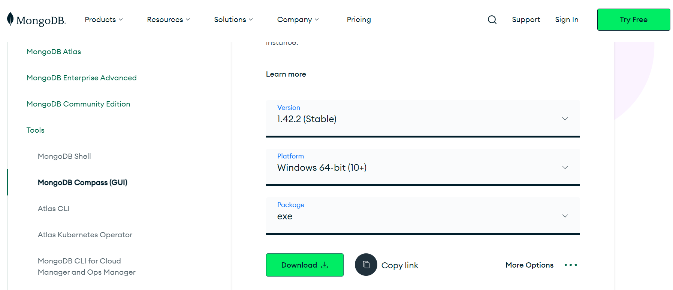
- Select your operating system.
- Click "Download" to start the download process.

Install MongoDB Compass
- Windows: Run the downloaded .exe installer and follow the on-screen instructions.
- macOS: Open the downloaded .dmg file, then drag and drop MongoDB Compass into your Applications folder.
- Linux: Depending on the package format, you might use a package manager like dpkg or rpm to install Compass. For example, sudo dpkg -i mongodb-compass_*.deb for Debian/Ubuntu, or sudo rpm -i mongodb-compass-*.rpm for Fedora/CentOS.

Verify Installation
Launch MongoDB Compass. If the installation was successful, MongoDB Compass should open and prompt you to connect to a MongoDB database.
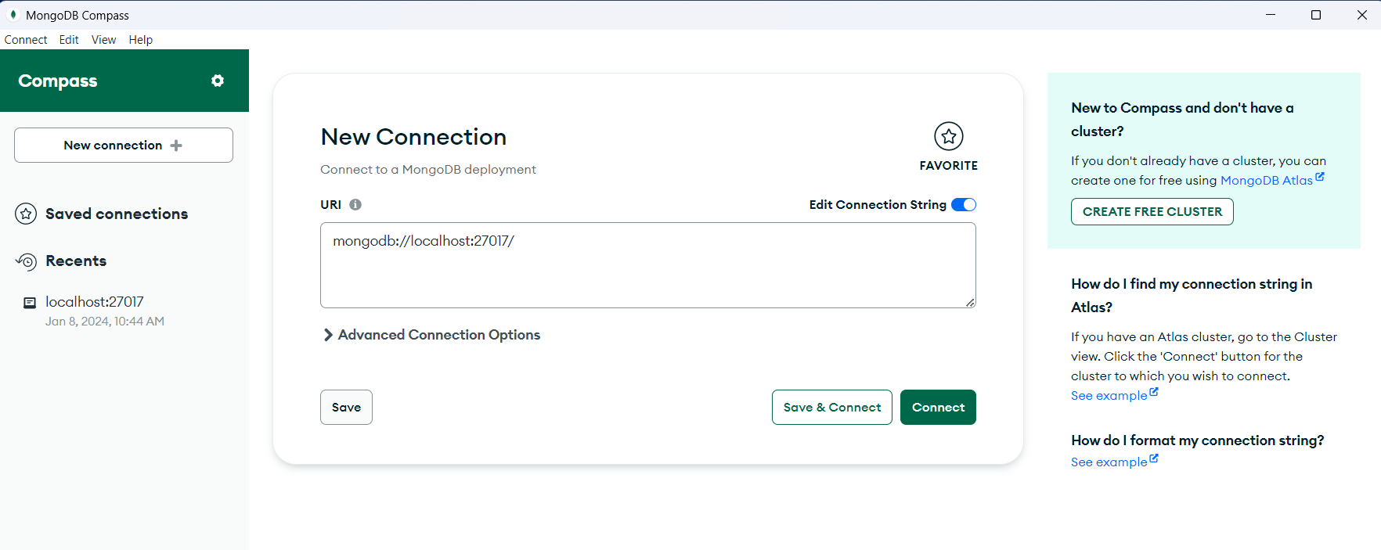
Remember, MongoDB Shell and MongoDB Compass are powerful tools for interacting with your MongoDB databases, offering both command-line and graphical interfaces for database management.

